Robin Scott Photography gives you the very best in preserving that special moment on film! We use only professional photographic equipment and accessories. There is no limit on the number of proofs we take. Our usual time frame to photograph a spectacular wedding memoir is approximately four hours. Call our office today. We can answer any questions you may have.
All wedding packages include:
Black &White Photo for Newspaper
An Album containing 12-15 Bridal Previews
A Deluxe Album with all Wedding Previews

Package A
includes above and your choice of 12 proofs enlarged to 8x10.…………...$895.00
Package B
includes above and your choice of 18 proofs enlarged to 8x10, with a Deluxe Album for proofs…………....$1,095.00
Package C
includes above and your choice of 24 - 8x10’s, 12 - 5x7’s, plus your favorite proof sized to 11x14. Deluxe Albums are provided for all proof……………………….……….$1,395.00

OUR VERY BEST

Package D
includes above plus 24–8x10’s, 12–5x7’s, and an incredible 16x20 Print Framed! A 4x5 mini-folio for the attendants is included, and Deluxe Albums are included to showcase your enlargements ……$1,750.00
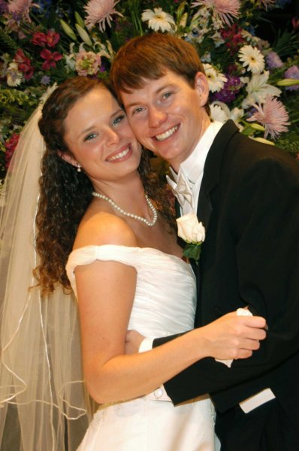

Additional portrait sizes available!

Scroll Down and See Page 2 for something

A lot of Brides are now going for a NEW way of getting their Wedding photography done. In this new way, our Photographer is contracted for a 3,4, or 5 hours. He takes UNLIMITED pictures. You then choose which pictures and the quantity you want from a sheet provided you by our Photographer. Many Brides like this because of the amount of pictures taken and their ability to select. You can order as many reprints as you want.

Flat Rate:

3 hours – 425.00
4 hours – 490.00
5 hours – 550.00

The following is your cost on the reprint pricing:

8x10 - $18 (each)
5x7 - (1) $9 (2) $18 (usually 2 on a sheet)
4x6 - $3.50 (each)
Wallets $6 (min. of 4)
11x14 - $65 (each)
16x20 - $95 (each)

Prices include retouching basic items (hair,blemishes etc.)
Any serious corrections call for a quote (opening eyes, removing major items or rearranging ).

